Classes 2: inheritance, polymorphism and containment
Y13 - Cambridge International 9618 | 20.1 | Student booklet
Name: _______________________________ | Date: _____________

This booklet has everything you need for the lesson in one place. Work through it in order:
- Learn sections show the key slides. Read them carefully - they explain the ideas and show worked examples.
- Task sections are where you practise. Each task uses what the slides just before it taught you.
- Tasks build up from a recap to real Cambridge 9618 Paper 3 and Paper 4 questions. Task 6 is homework or for the next lesson at the computer.
Learn Starter - recap of lesson 1
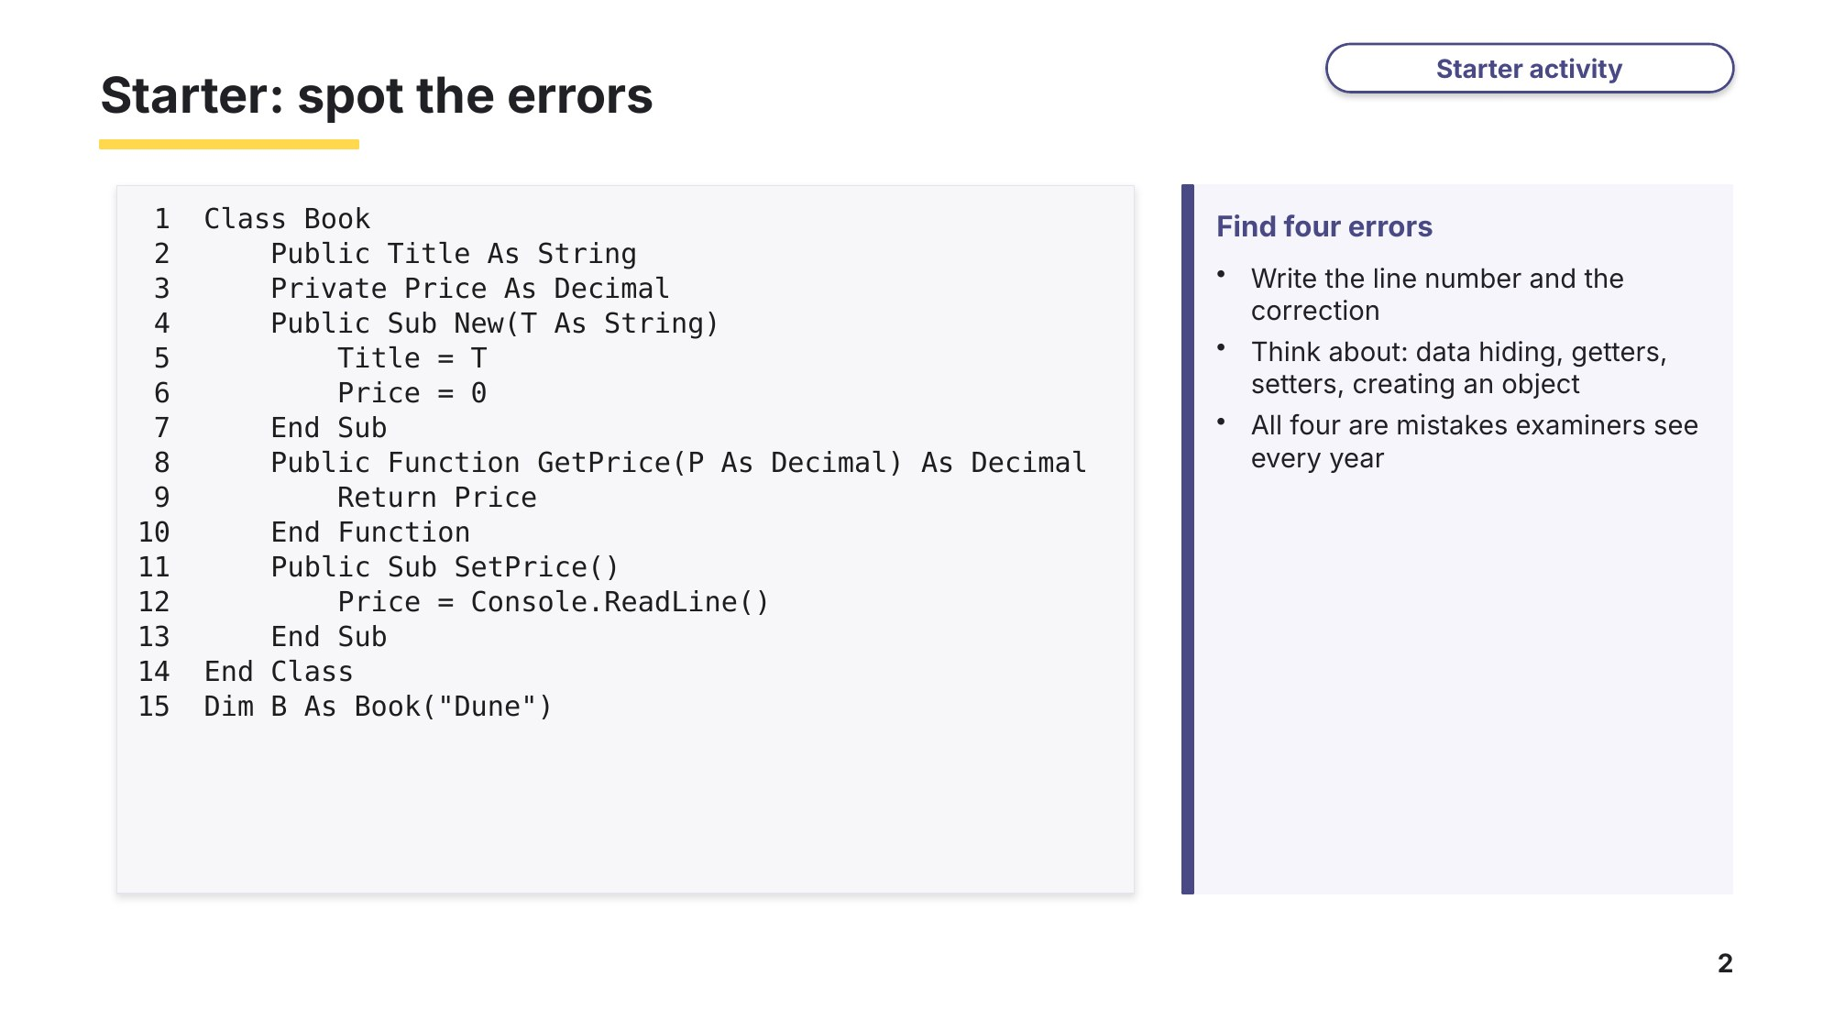
Slide 2 - Starter: spot the errors

Task 1 Starter: spot the errors [4 marks]
This class and main program contain four errors. Each one is a mistake examiners see every year. Write the line number of each error and how to correct it.
1 Class Book
2 Public Title As String
3 Private Price As Decimal
4 Public Sub New(T As String)
5 Title = T
6 Price = 0
7 End Sub
8 Public Function GetPrice(P As Decimal) As Decimal
9 Return Price
10 End Function
11 Public Sub SetPrice()
12 Price = Console.ReadLine()
13 End Sub
14 End Class
15 Dim B As Book("Dune")
Line | Correction

Learn Getters, setters and inheritance
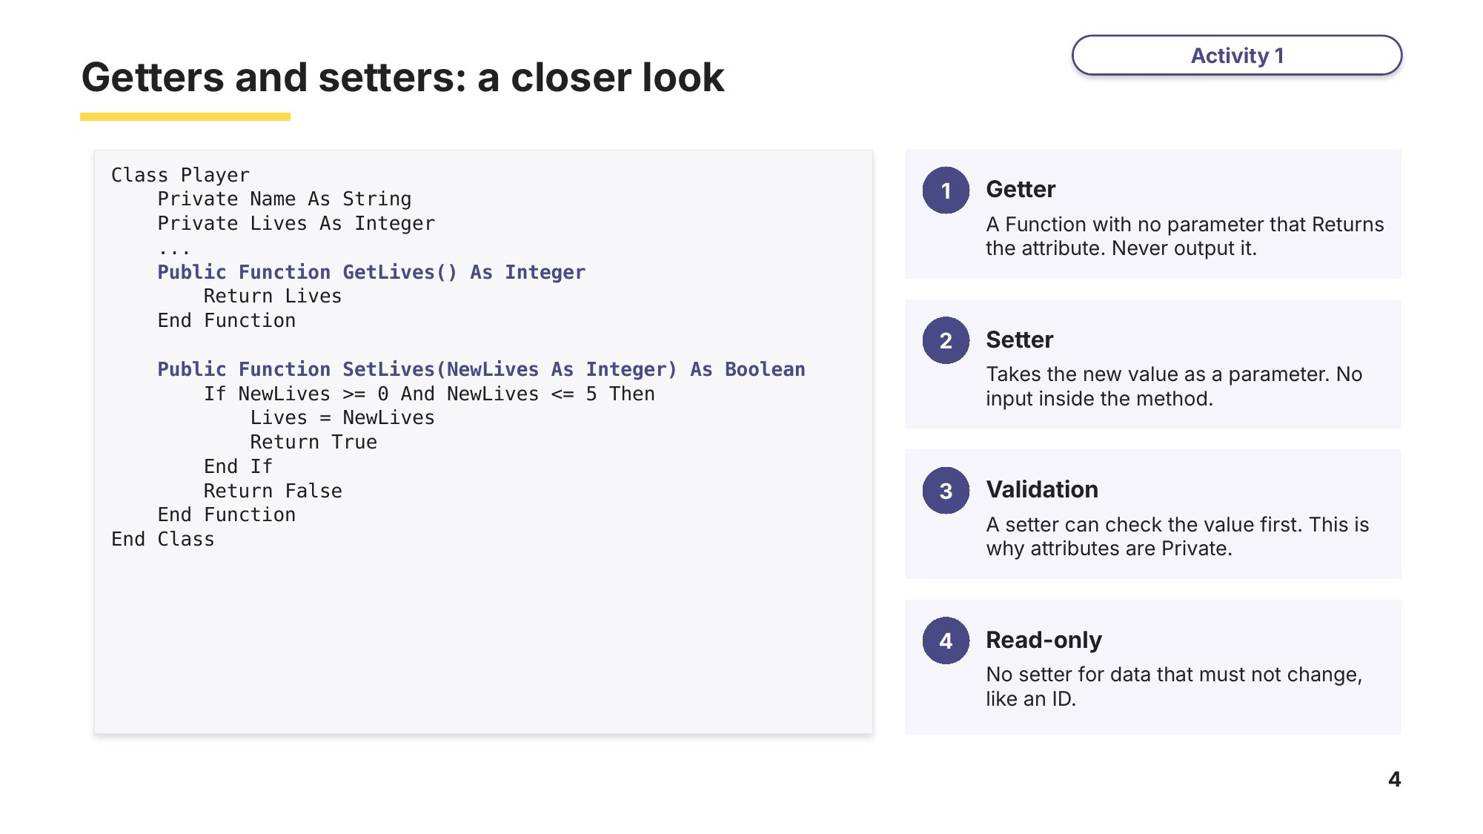
Slide 4 - Getters and setters: a closer look
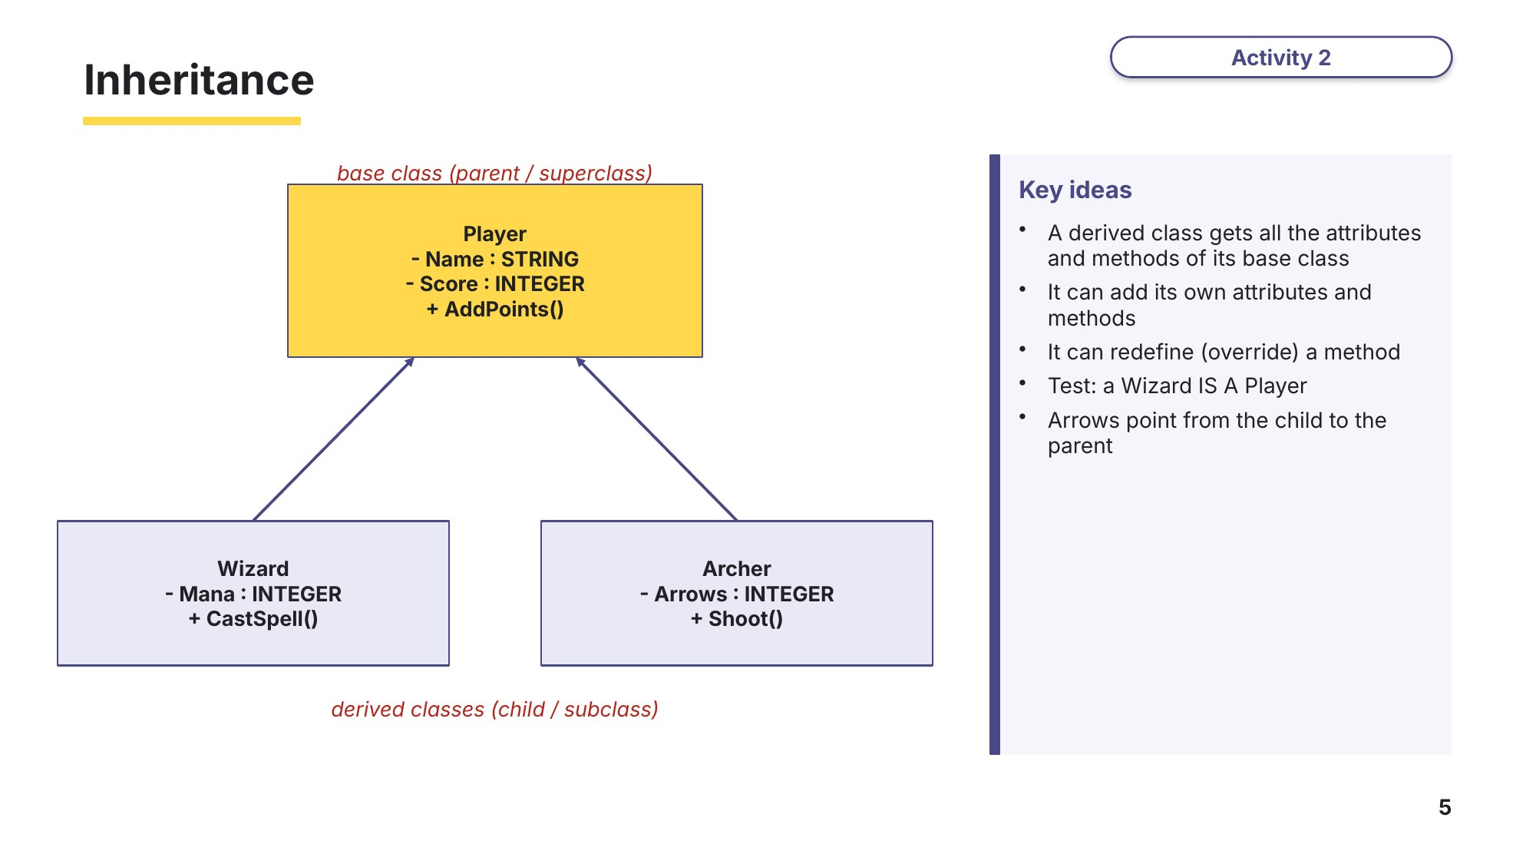
Slide 5 - Inheritance
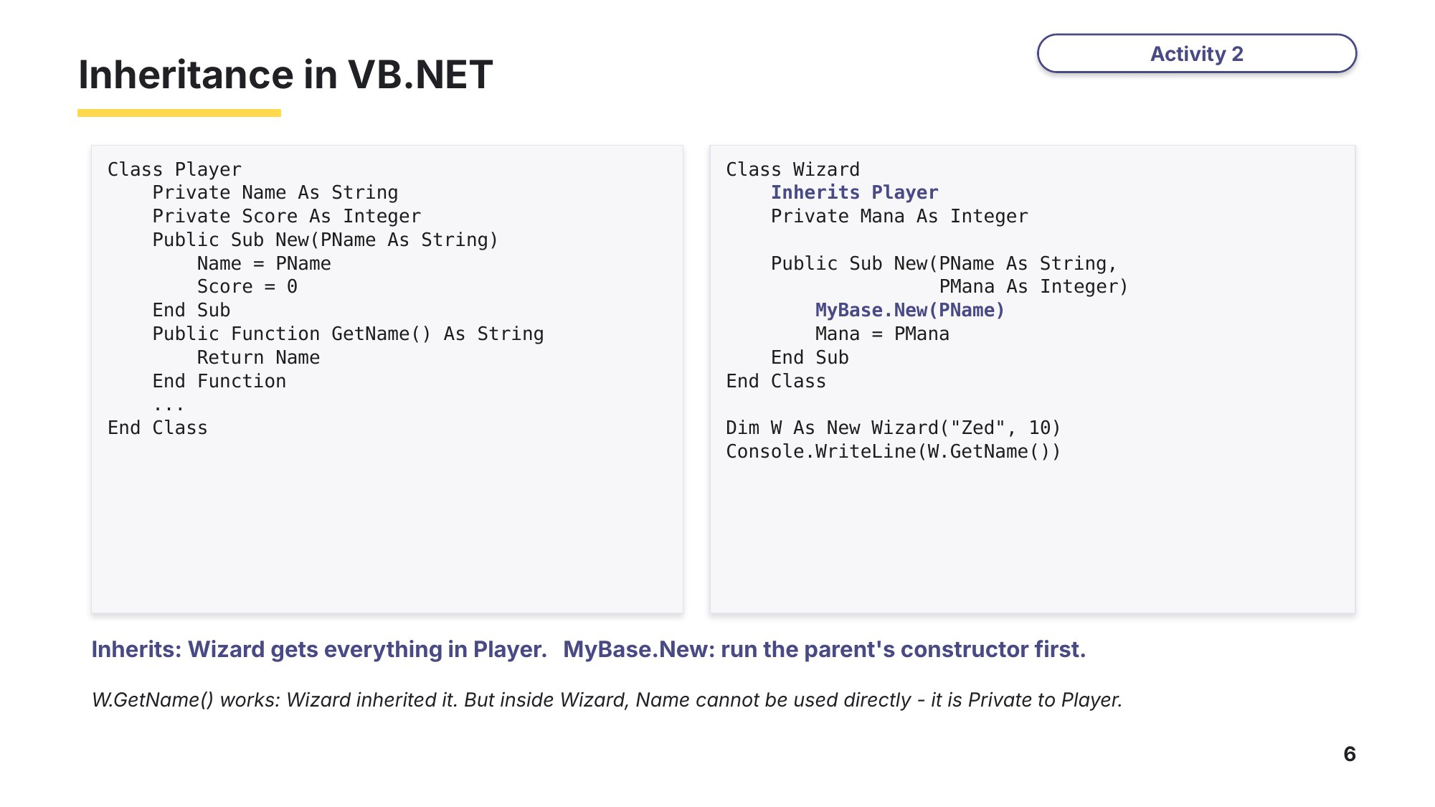
Slide 6 - Inheritance in VB.NET
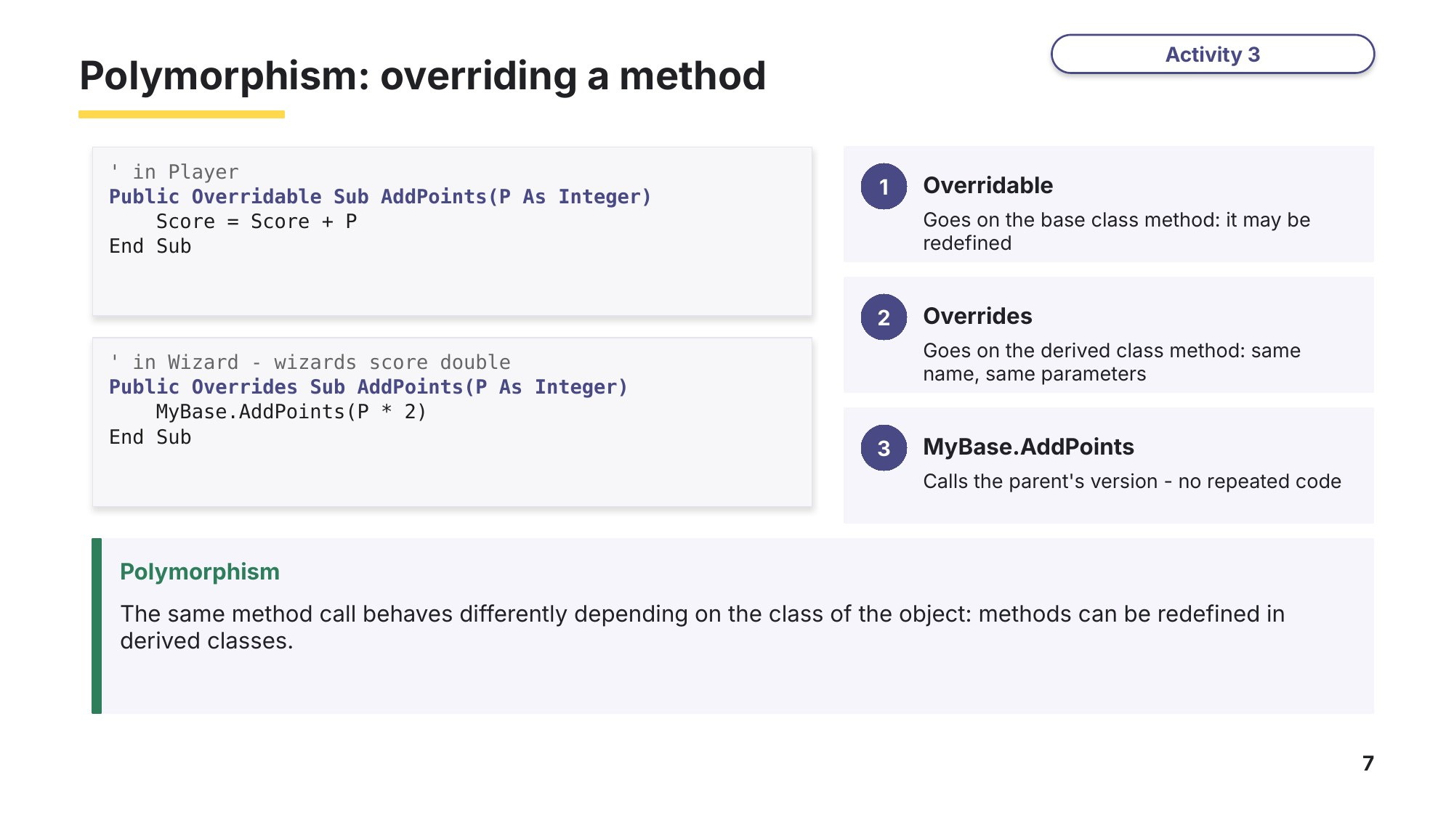
Slide 7 - Polymorphism: overriding a method

Learn Polymorphism, overloading and containment
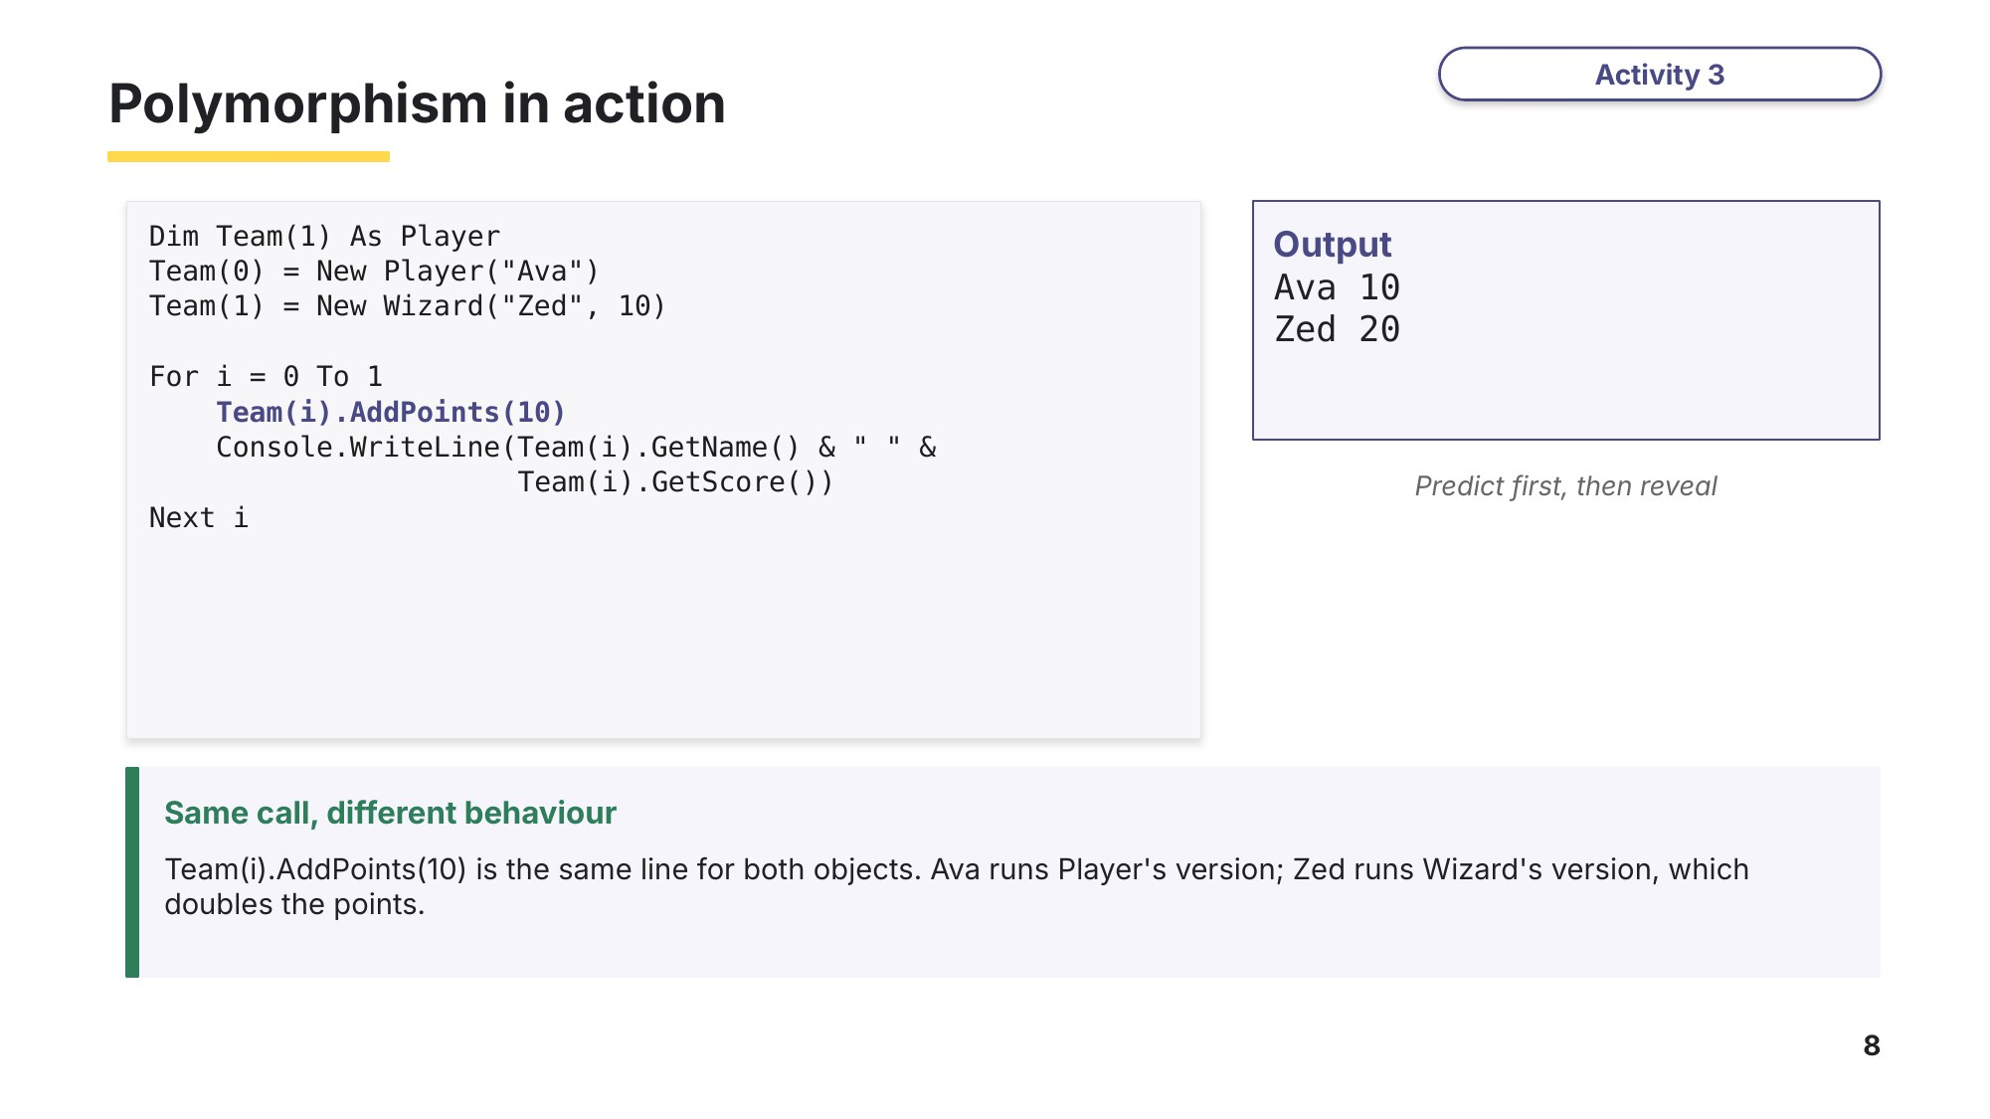
Slide 8 - Polymorphism in action
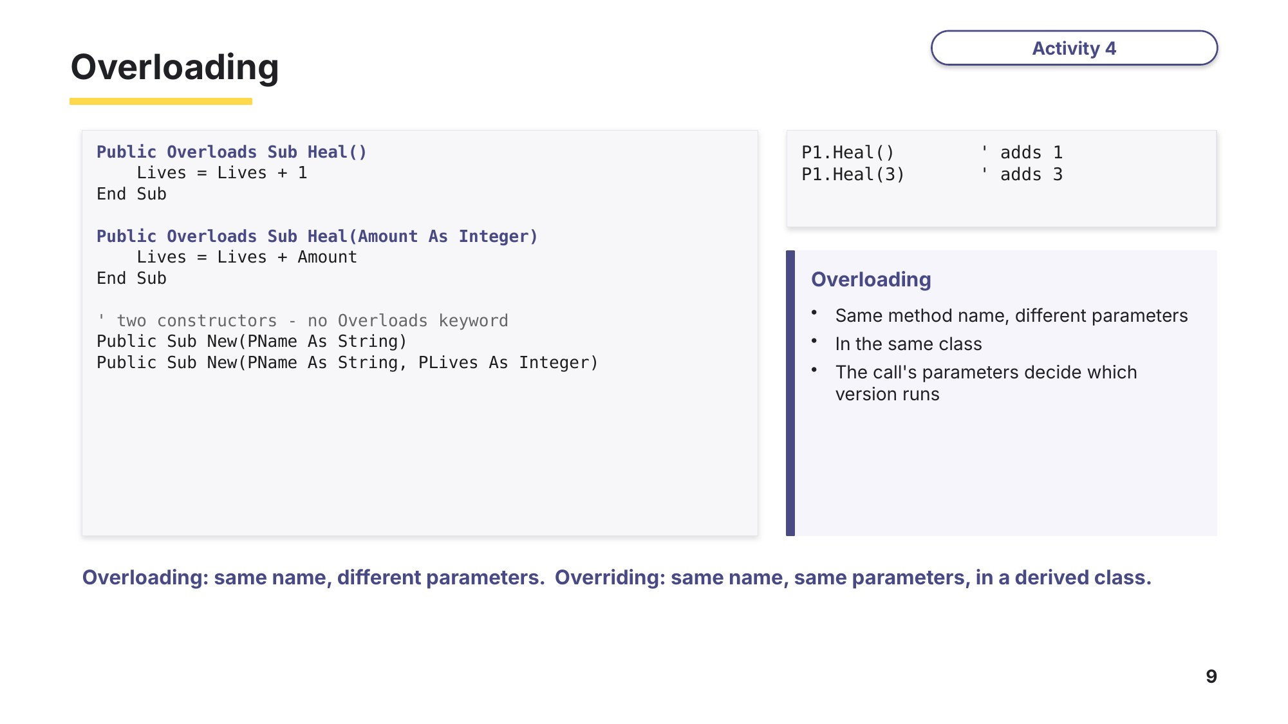
Slide 9 - Overloading
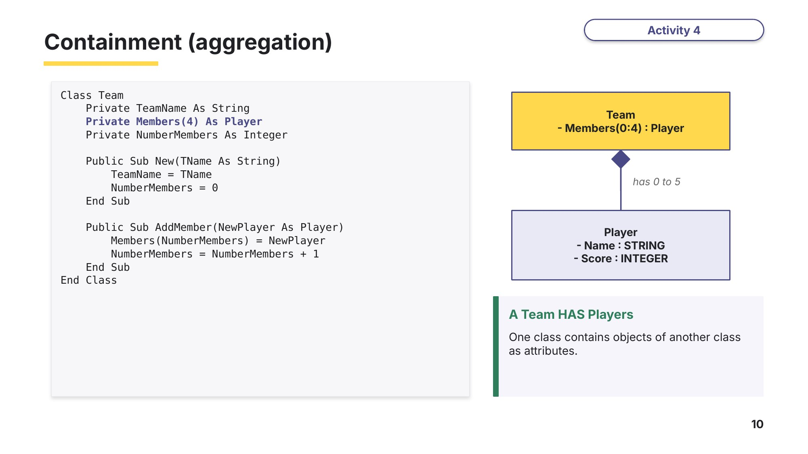
Slide 10 - Containment (aggregation)
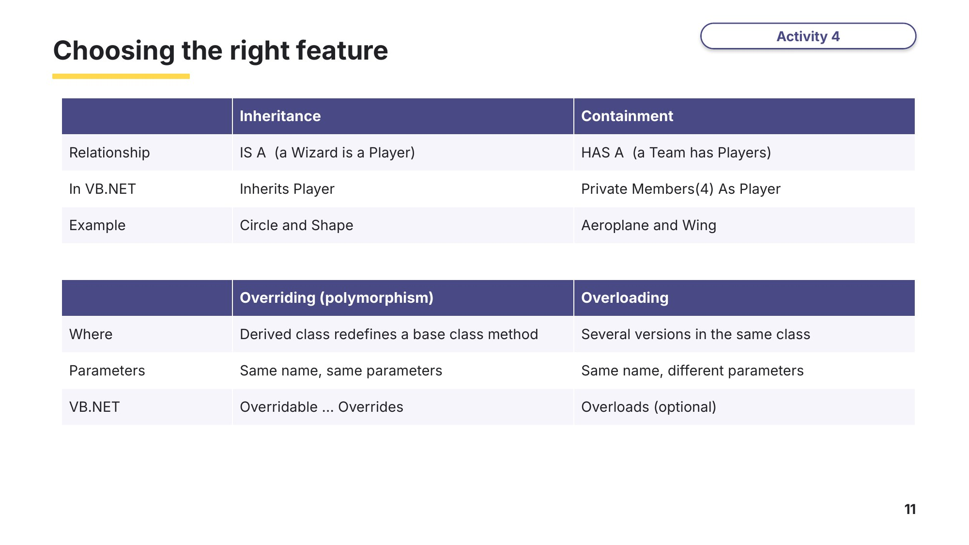
Slide 11 - Choosing the right feature
Task 2 OOP key words [10 marks]
(a) Write the letter of the correct description next to each term. One description is not used. [6]
Term | Letter |  | Description
Inheritance |  | A | The class whose attributes and methods are passed on to another class
Polymorphism |  | B | A class that takes the attributes and methods of another class and can add its own
Overloading |  | C | One class contains objects of another class as attributes
Containment |  | D | Defining a new class that has all the attributes and methods of a parent class
Base class |  | E | A method redefined in a derived class, so the same call behaves differently for different classes
Derived class |  | F | Removing an object from memory when it is no longer needed
 |  | G | The same method name used more than once in a class, with different parameters

(b) For each pair of classes, write inheritance or containment, and complete the sentence. [4]
Classes | Inheritance or containment? | Because a ...
Car and Engine |  | car ............ an engine
Car and Vehicle |  | car ............ a vehicle
Library and Book |  | library ............ books
Teacher and Person |  | teacher ............ a person
Task 3 Read and trace inheritance [9 marks]
A zoo program uses these classes.
Class Animal
Private Name As String
Private Legs As Integer
Public Sub New(N As String, L As Integer)
Name = N
Legs = L
End Sub
Public Function GetName() As String
Return Name
End Function
Public Overridable Function Describe() As String
Return Name & " has " & Legs & " legs"
End Function
End Class
Class Parrot
Inherits Animal
Private Words As Integer
Public Sub New(N As String, W As Integer)
MyBase.New(N, 2)
Words = W
End Sub
Public Sub Learn()
Words = Words + 1
End Sub
Public Overrides Function Describe() As String
Return MyBase.Describe() & " and knows " & Words & " words"
End Function
End Class
Class Fish
Inherits Animal
Public Sub New(N As String)
MyBase.New(N, 0)
End Sub
Public Overrides Function Describe() As String
Return GetName() & " swims"
End Function
End Class
(a) Identify the base class and one derived class. [1]

(b) Explain what the line MyBase.New(N, 2) does in the Parrot constructor. [2]

(c) The Fish method Describe() uses GetName() instead of Name. Explain why. [1]

(d) Explain why Describe() in Animal is declared as Overridable. [1]

(e) This main program uses the classes. Write down the output. [3]
Dim Zoo(2) As Animal
Dim P As New Parrot("Polly", 3)
P.Learn()
P.Learn()
Zoo(0) = New Animal("Rex", 4)
Zoo(1) = P
Zoo(2) = New Fish("Nemo")
For i = 0 To 2
Console.WriteLine(Zoo(i).Describe())
Next i

(f) Name the OOP feature shown when Zoo(i).Describe() gives a different result for each object. [1]

Task 4 Complete the code [8 marks]
A bank has a class Account. A LimitAccount is an account that only allows withdrawals up to a maximum amount. Complete the VB.NET code by filling in the six gaps.
Class Account
Private Balance As Decimal
Public Sub New(Start As Decimal)
Balance = Start
End Sub
Public Function GetBalance() As Decimal
Return Balance
End Function
Public (1).............. Function Withdraw(Amount As Decimal) As Boolean
If Amount <= Balance Then
Balance = Balance - Amount
Return True
End If
Return False
End Function
Public (2).............. Sub Deposit(Amount As Decimal)
Balance = Balance + Amount
End Sub
Public Overloads Sub Deposit(Amount As Decimal, Times As Integer)
Balance = Balance + Amount * Times
End Sub
End Class
Class LimitAccount
(3).............. Account
Private MaxWithdraw As Decimal
Public Sub New(Start As Decimal, Max As Decimal)
(4)..............(Start)
MaxWithdraw = Max
End Sub
Public (5).............. Function Withdraw(Amount As Decimal) As Boolean
If Amount > MaxWithdraw Then
Return False
End If
Return (6)...........Withdraw(Amount)
End Function
End Class
Gap | Answer | Gap | Answer
(1) |  | (4)
(2) |  | (5)
(3) |  | (6)

(b) Identify the method that is overloaded and explain how the program decides which version to run. [2]

Learn A binary tree with classes
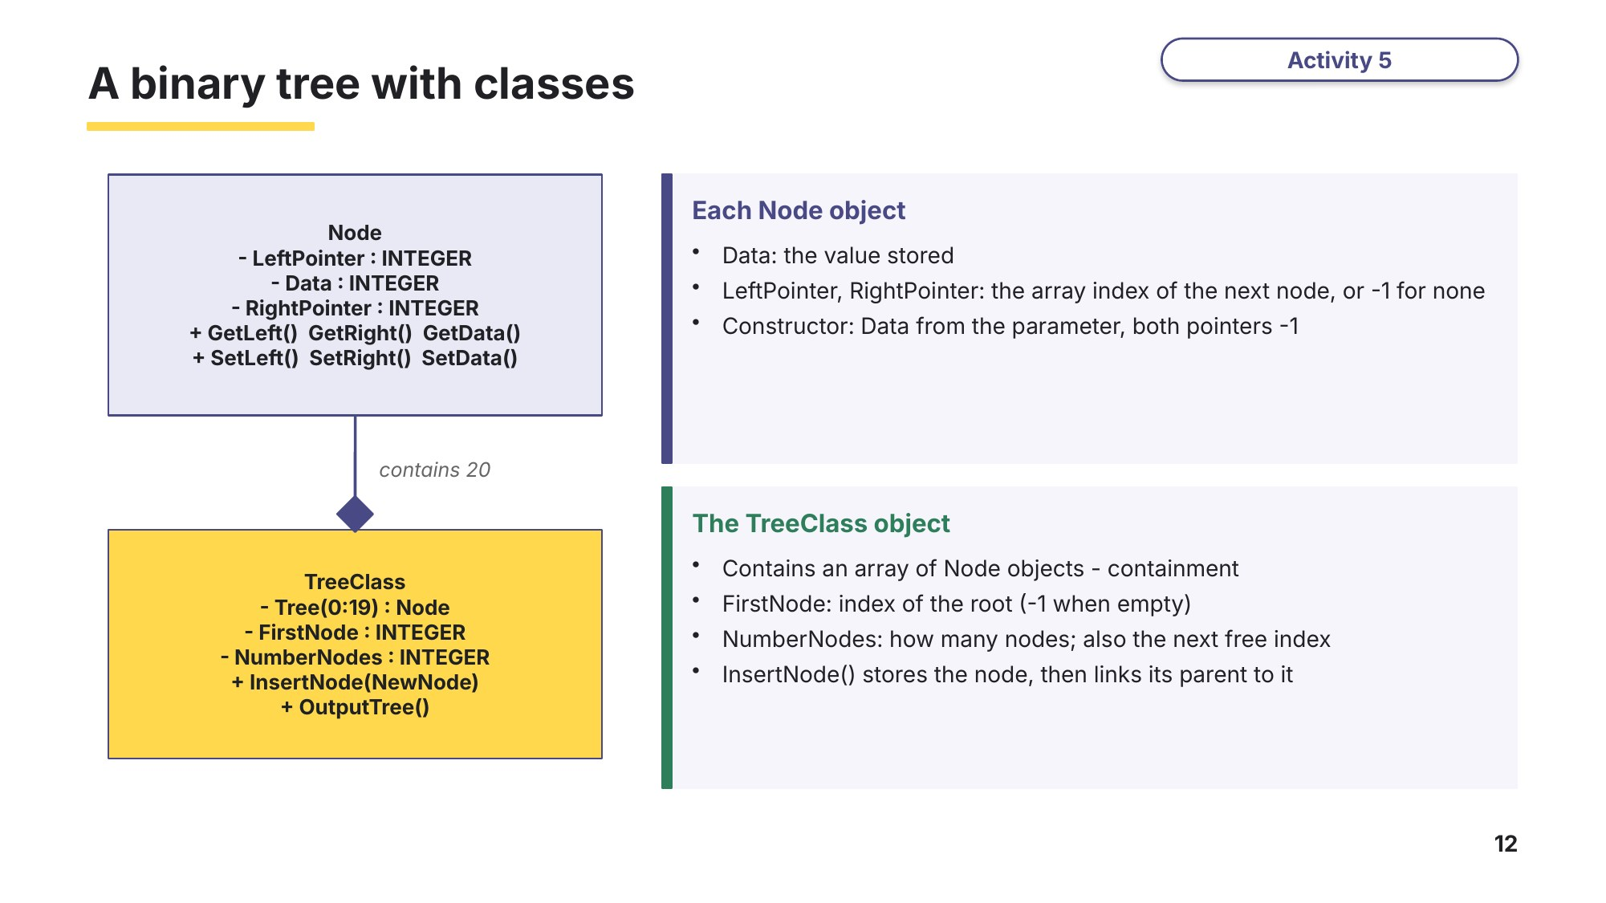
Slide 12 - A binary tree with classes
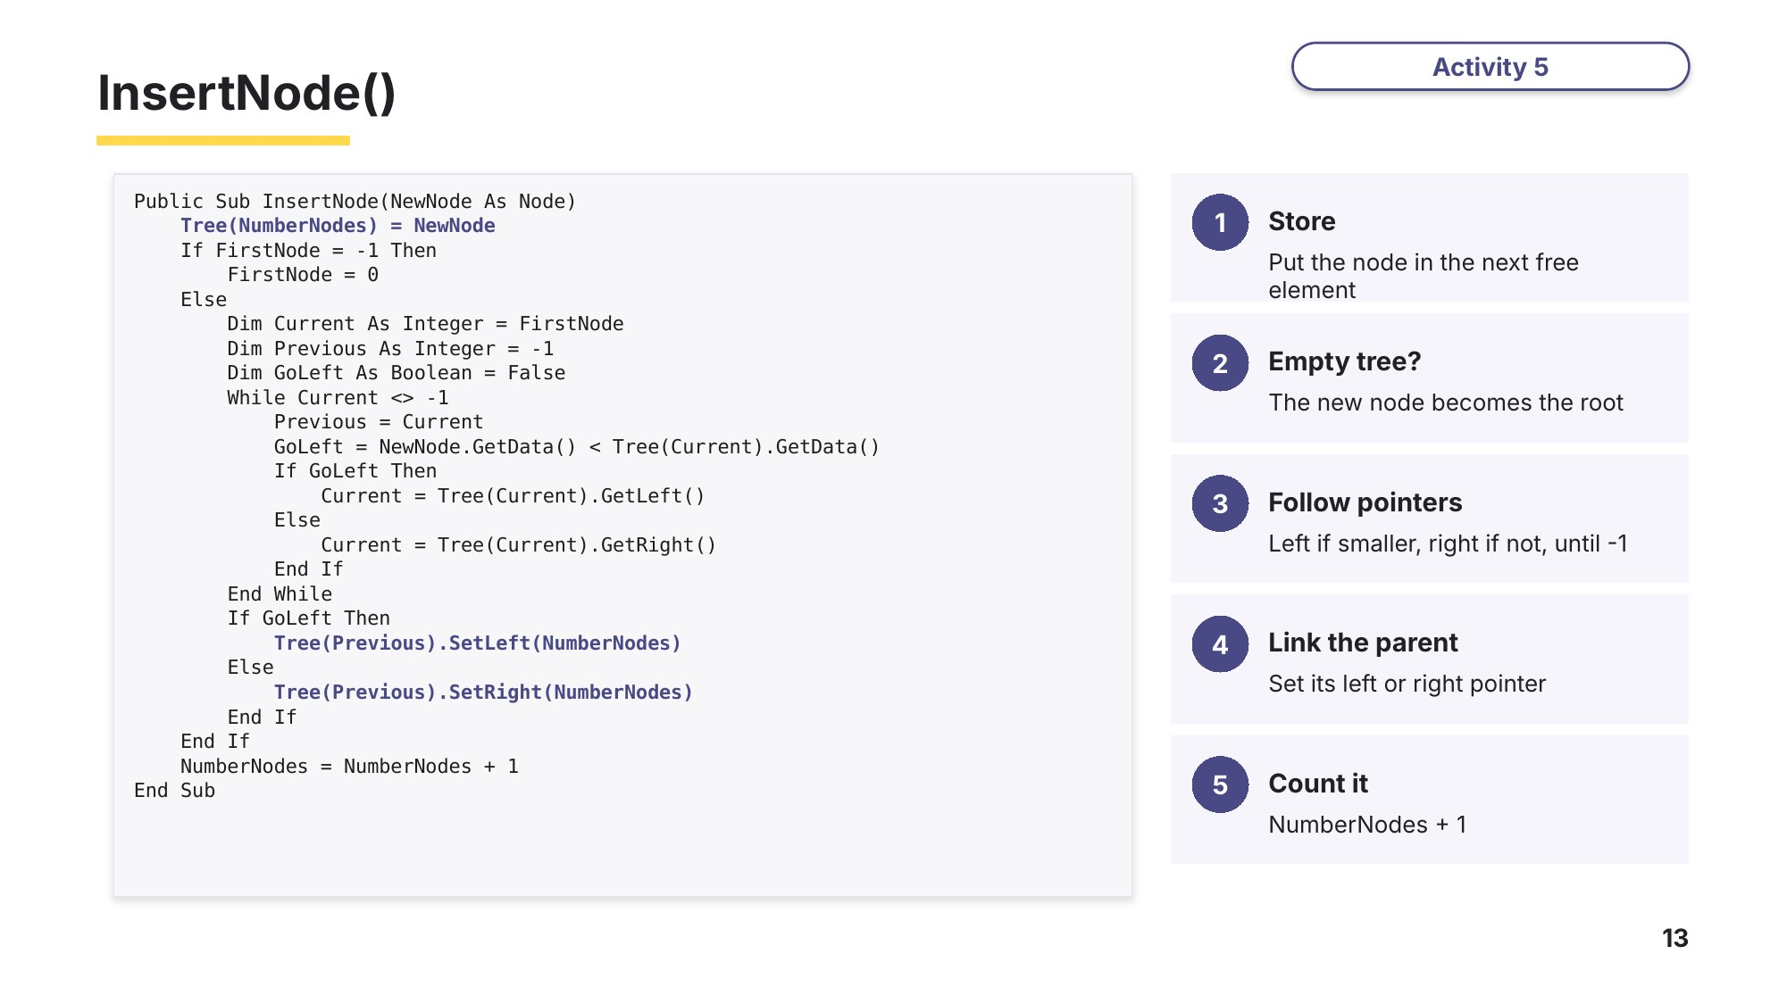
Slide 13 - InsertNode()
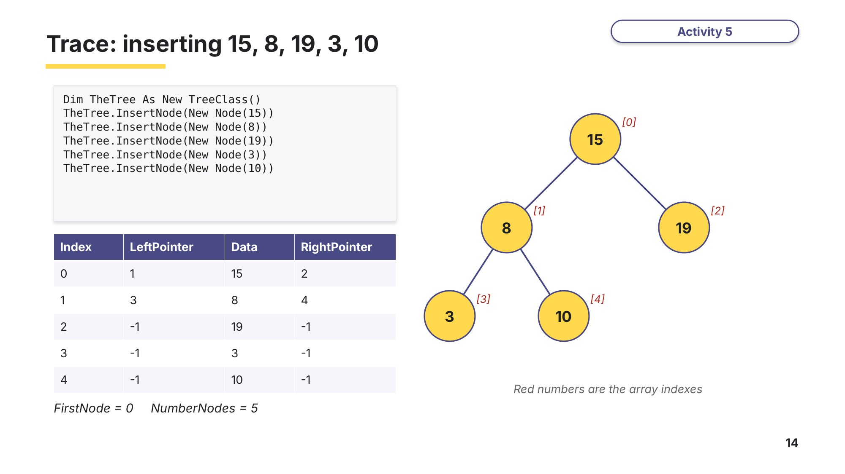
Slide 14 - Trace: inserting 15, 8, 19, 3, 10
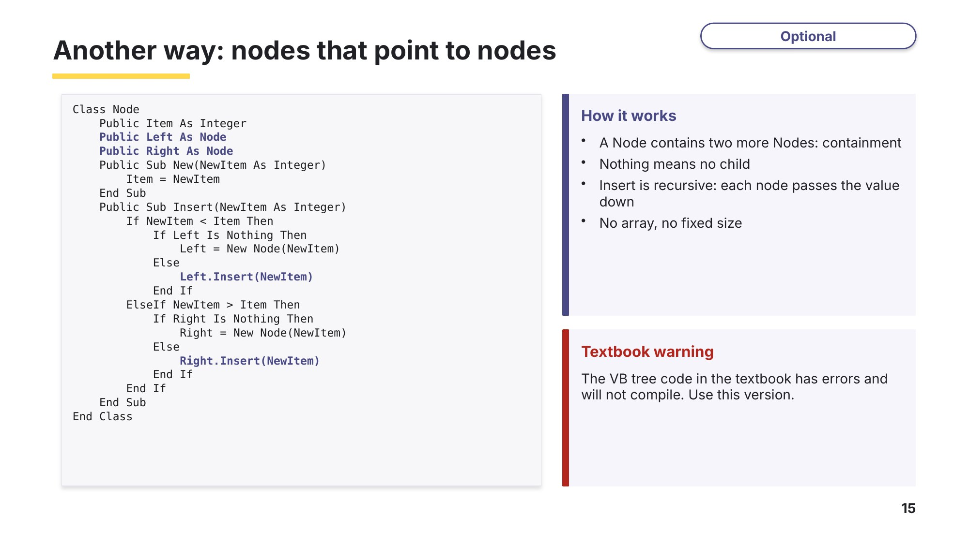
Slide 15 - Another way: nodes that point to nodes (optional)
Task 5 A binary tree with classes [10 marks]
A program stores integers in a binary tree using the classes Node and TreeClass, and the method InsertNode() from the slides. Each node is stored in the array Tree in the order it is inserted. -1 is a null pointer.
Node
LeftPointer : INTEGER index of the node to the left, or -1
Data : INTEGER the node's data
RightPointer : INTEGER index of the node to the right, or -1
Constructor() sets Data to the parameter; both pointers to -1
GetLeft() GetRight() GetData() SetLeft() SetRight() SetData()

TreeClass
Tree(0:19) : Node array of 20 Node objects
FirstNode : INTEGER index of the root, -1 when the tree is empty
NumberNodes : INTEGER number of nodes stored (also the next free index)
InsertNode(NewNode) stores NewNode and updates its parent's pointer

(a) The main program inserts 50, 30, 70, 20, 40, 60 in this order. Complete the table and the values of FirstNode and NumberNodes. [6]
Index | LeftPointer | Data | RightPointer
0
1
2
3
4
5
FirstNode .......................... NumberNodes ..........................
(b) Draw the binary tree. [1]
(c) TreeClass has an attribute that is an array of Node objects. Identify this OOP feature. [1]

(d) Write VB.NET code for the getter GetData(). [2]

Learn How examiners mark inheritance
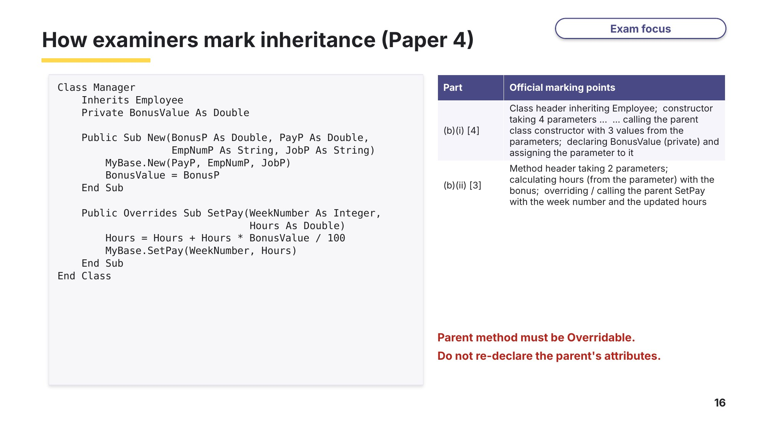
Slide 16 - How examiners mark inheritance (Paper 4)
Task 6 Real exam questions - homework or next lesson [63 marks]
Part A - Paper 3 (written answers)
(a) Define these Object-Oriented Programming (OOP) terms: [3]
9618/31 October/November 2022 Q11(a).
Instance

Inheritance

Polymorphism

(b) Identify the object-oriented programming (OOP) feature whose function includes restricting external access to the data. [1]
9618/31 May/June 2025 Q11(b)(i).

(c) Describe what is meant by the OOP feature inheritance. [2]
9618/31 May/June 2025 Q11(b)(ii).

(d) Identify the object-oriented programming (OOP) term described as 'an occurrence of an object'. [1]
9618/32 May/June 2025 Q12(b)(i).

(e) Describe what is meant by the OOP term polymorphism. [2]
9618/32 May/June 2025 Q12(b)(ii).

Part B - Paper 4 (at the computer, VB.NET)
9618/41 May/June 2023 Q2. Write your code in your evidence document, as in the real exam.
A computer game is being designed that will include different vehicles. A prototype for the game is being developed using object-oriented programming.
The class Vehicle stores data about the vehicles. Each vehicle has an identification name, a maximum speed, a current speed and a horizontal position. The value IncreaseAmount is added to the current speed each time the vehicle increases its speed.
Vehicle
ID : STRING stores the identification name for the vehicle
MaxSpeed : INTEGER stores the maximum speed
CurrentSpeed : INTEGER stores the current speed
IncreaseAmount : INTEGER stores the amount CurrentSpeed increases by
HorizontalPosition : INTEGER stores the horizontal position
Constructor() initialises ID, MaxSpeed and IncreaseAmount to the
parameter values; initialises both CurrentSpeed
and HorizontalPosition to 0
GetCurrentSpeed() returns the current speed
GetIncreaseAmount() returns the increase amount
GetHorizontalPosition() returns the horizontal position
GetMaxSpeed() returns the maximum speed
SetCurrentSpeed() assigns the parameter to the current speed
SetHorizontalPosition() assigns the parameter to the horizontal position
IncreaseSpeed() calculates and stores the new speed and horizontal
position of the vehicle

(f) Write program code to declare the class Vehicle. All attributes must be private. You only need to declare the class and its constructor. Do not declare any other methods. [5]
(g) Write program code for the get methods GetCurrentSpeed(), GetIncreaseAmount(), GetMaxSpeed() and GetHorizontalPosition(). [3]
(h) Write program code for the set methods SetCurrentSpeed() and SetHorizontalPosition(). [3]
(i) The method IncreaseSpeed() adds IncreaseAmount to the current speed, and adds the updated current speed to the horizontal position. The current speed of a vehicle cannot exceed its maximum speed. Write program code for the method IncreaseSpeed(). [3]

The child class Helicopter inherits from the parent class Vehicle. A helicopter also has a vertical position and changes the vertical position when it increases speed.
Helicopter
VerticalPosition : INTEGER stores the vertical position
VerticalChange : INTEGER stores the amount VerticalPosition changes by
MaxHeight : INTEGER stores the maximum height the helicopter can reach
Constructor() takes the ID, maximum speed, increase amount, vertical
change and maximum height as parameters;
initialises the vertical position to 0
GetVerticalPosition() returns the vertical position
IncreaseSpeed() changes the current speed, horizontal and vertical
position of the helicopter

(j) Write program code to declare the class Helicopter. You only need to declare the class and its constructor. All attributes must be private. [5]
(k) The Helicopter method IncreaseSpeed() overrides the method from the parent class and: adds the amount of vertical change to the vertical position; adds IncreaseAmount to the current speed; adds the updated current speed to the horizontal position. The vertical position cannot exceed its maximum height. The current speed cannot exceed its maximum speed. Write program code for the method IncreaseSpeed(). [4]
(l) A procedure needs to output the horizontal position and speed of a vehicle. If the vehicle is a helicopter, it also outputs the vertical position. All outputs must include appropriate messages. Write program code for this procedure. [3]
(m) The main program needs to: instantiate a car as a new vehicle with the ID "Tiger", a maximum speed of 100 and an increase amount of 20; instantiate a new helicopter with the ID "Lion", a maximum speed of 350, an increase amount of 40, a vertical change of 3 and a maximum height of 100; call IncreaseSpeed() twice for the car and then call the output procedure for the car; call IncreaseSpeed() twice for the helicopter and then call the output procedure for the helicopter. Write program code for the main program, then test it. [5]
Part C - Extension: Paper 4 binary tree with classes
9618/42 May/June 2024 Q2. The classes Node and TreeClass are as in Task 5 (Node also has a constructor that takes the data as its parameter).
(n) Write program code to declare the class Node and its constructor. Do not declare the other methods. [4]
(o) Write program code to declare the class TreeClass and its constructor. The constructor initialises FirstNode to -1 and NumberNodes to 0, and initialises each element in Tree to a Node object with the data value of -1. Do not declare the other methods. [4]
(p) Write program code for InsertNode(), which takes a Node object, NewNode, as a parameter and inserts it into the array Tree as described in Task 5. [6]
(q) The method OutputTree() outputs the left pointer, the data and the right pointer for each node that has been inserted into the tree, in the order they are saved in the array. If there are no nodes in the array, it outputs 'No nodes'. Write program code for OutputTree(). [4]
(r) The main program declares an instance of TreeClass with the identifier TheTree, inserts 10, 11, 5, 1, 20, 7, 15 in this order and then calls OutputTree(). Write program code for the main program. [5]

Learn Exam technique - check your Task 6 Part A answers
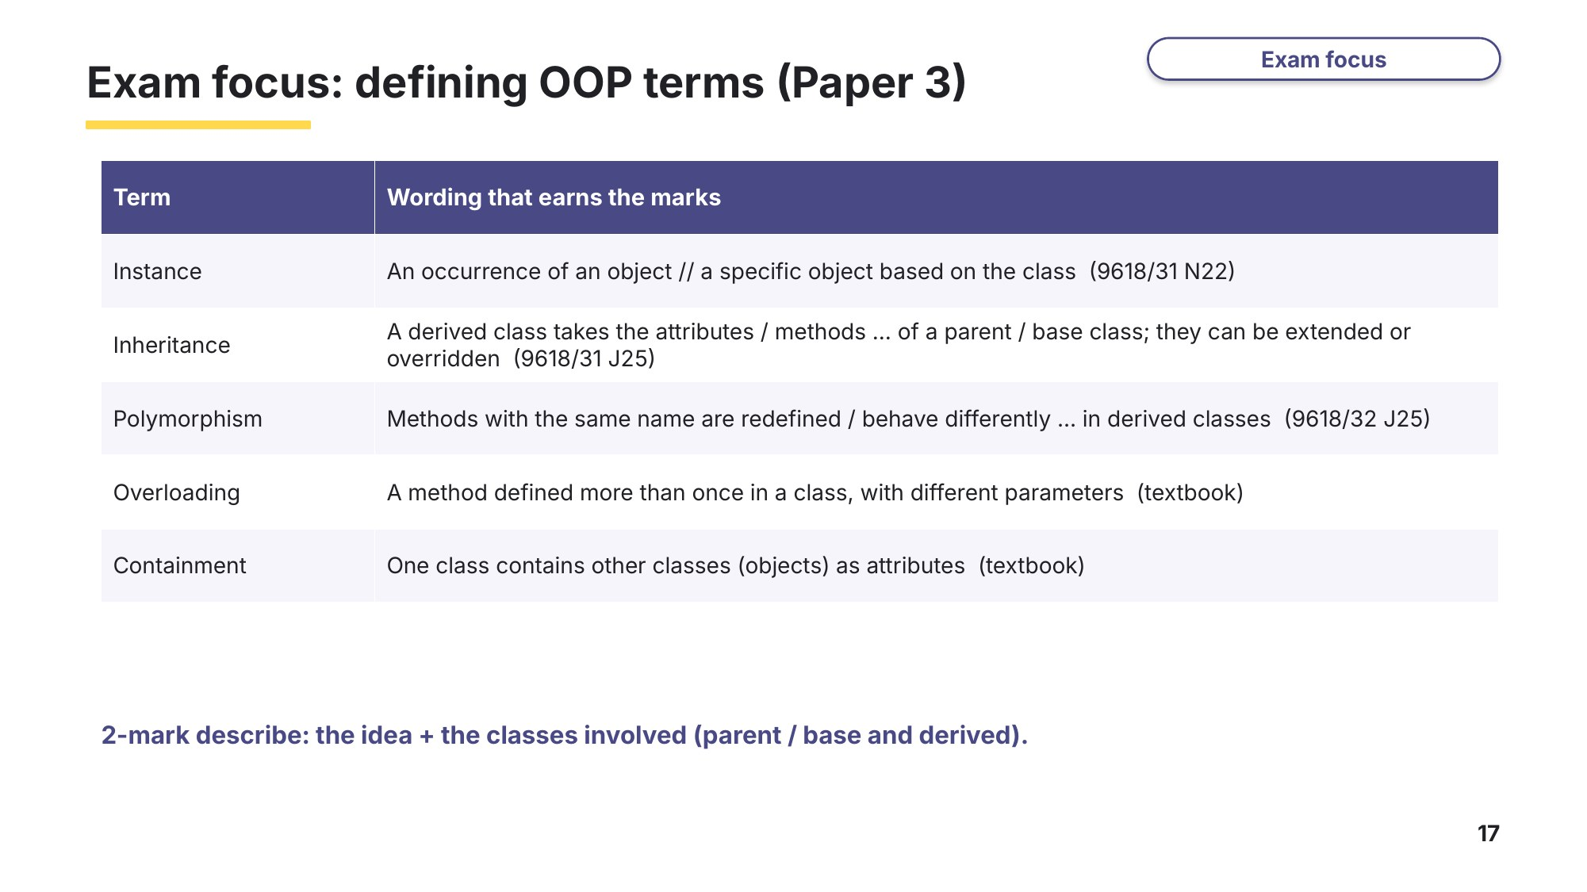
Slide 17 - Exam focus: defining OOP terms (Paper 3)
Learn Review
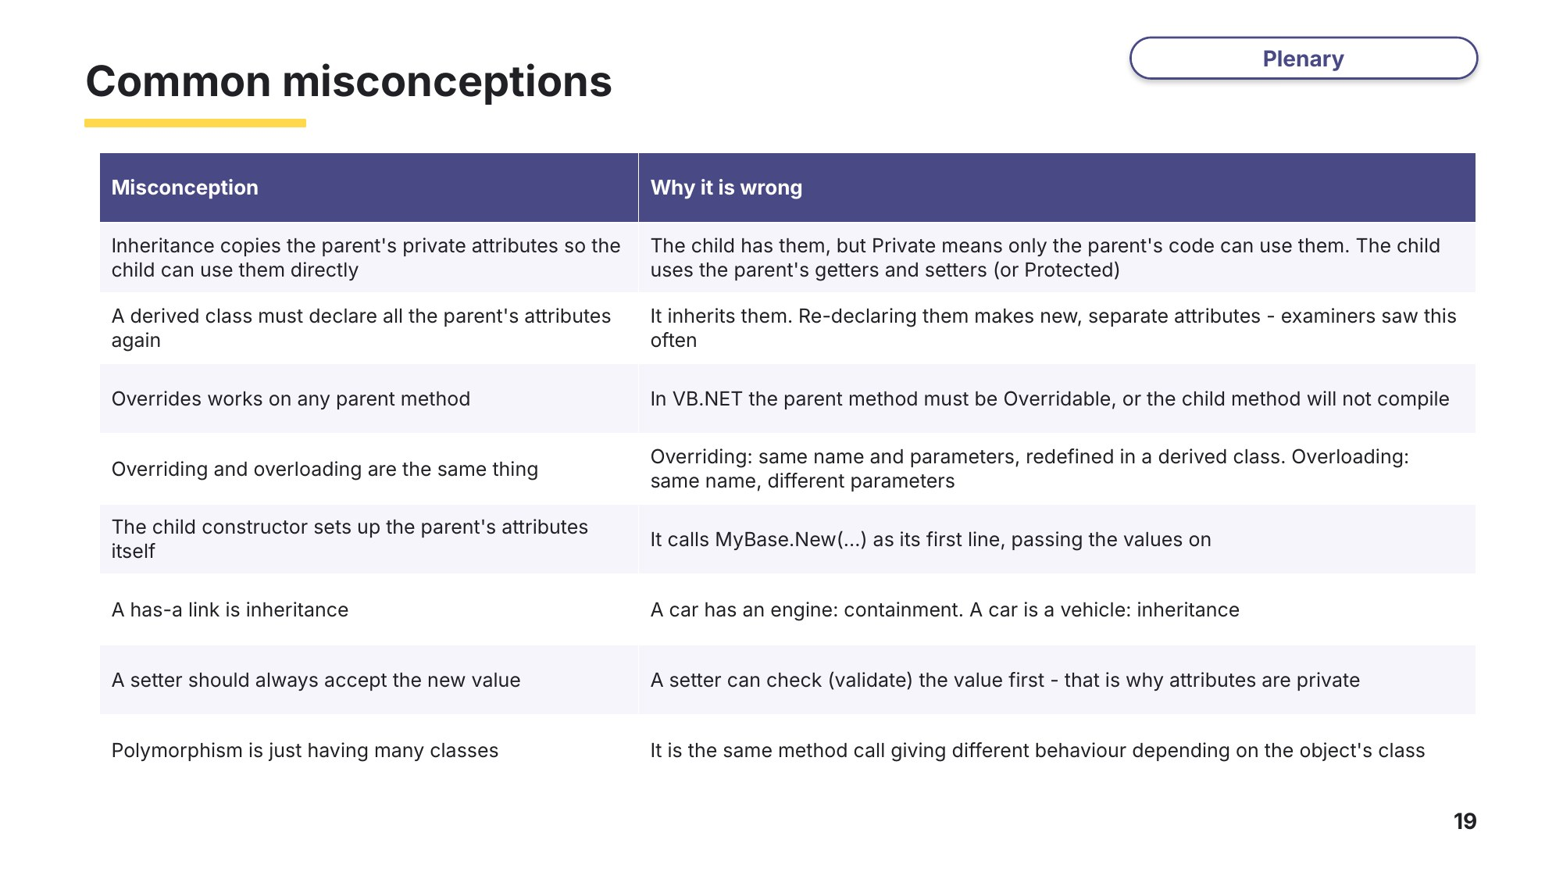
Slide 19 - Common misconceptions
Which of these did you believe before this lesson?
Exit question
(a) Explain the difference between overriding and overloading a method. [2]

(b) Class Car and class Engine: inheritance or containment? Give a reason. [1]

(c) Dog inherits Animal, whose constructor is New(AName As String, ALegs As Integer). Write the first line of the Dog constructor New(DName As String). [1]

